Week-4: Sample Digital Program

**1.**

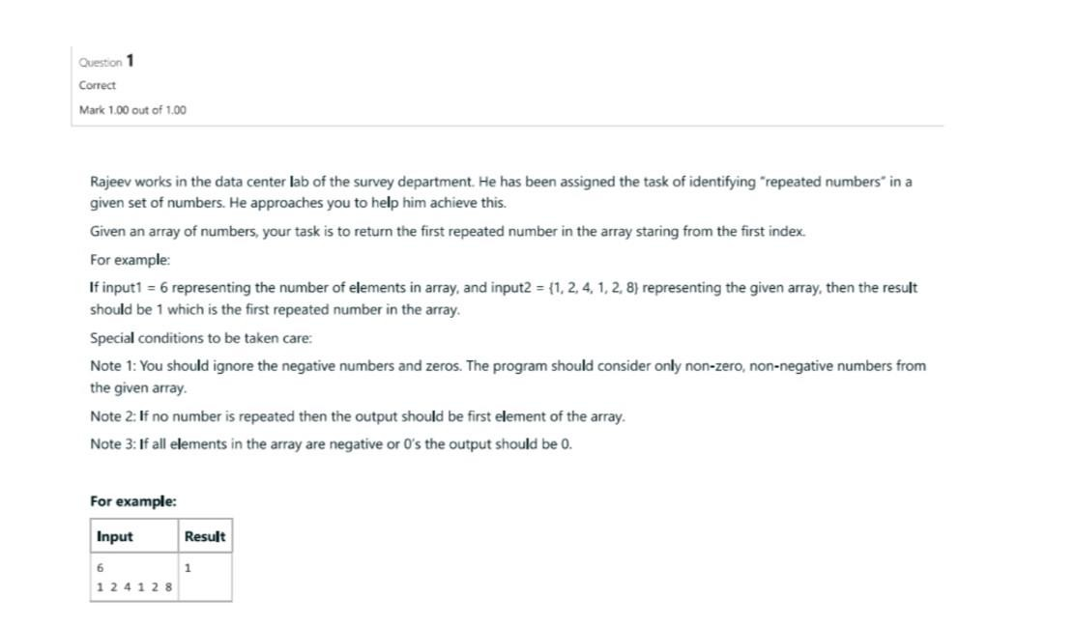 import java.util.Scanner; class Repeat{ public static void main(String[] args){

Scanner s=new Scanner(System.in);

System.out.println("Enter number of elements in array:"); int size=s.nextInt(); int[] array = new int[size];

System.out.println("Enter " + size + " elements:");

for (int i = 0; i < size; i++) { array[i] = s.nextInt();

}

boolean foundRepeat = false; for (int i = 0; i < size; i++) { for (int j = i + 1; j < size; j++) { if (array[i] == array[j]) {

System.out.println("First repeated number: " + array[i]);

foundRepeat = true;

break; }

} if (foundRepeat) { break;

}

}

if (!foundRepeat) {

System.out.println("No repeated numbers found.");

}

s.close();

}

}

**Output:**

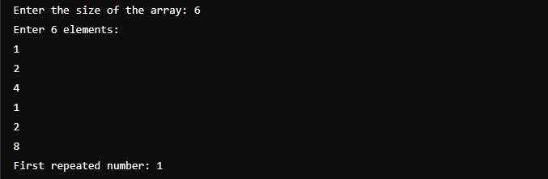

**2.**

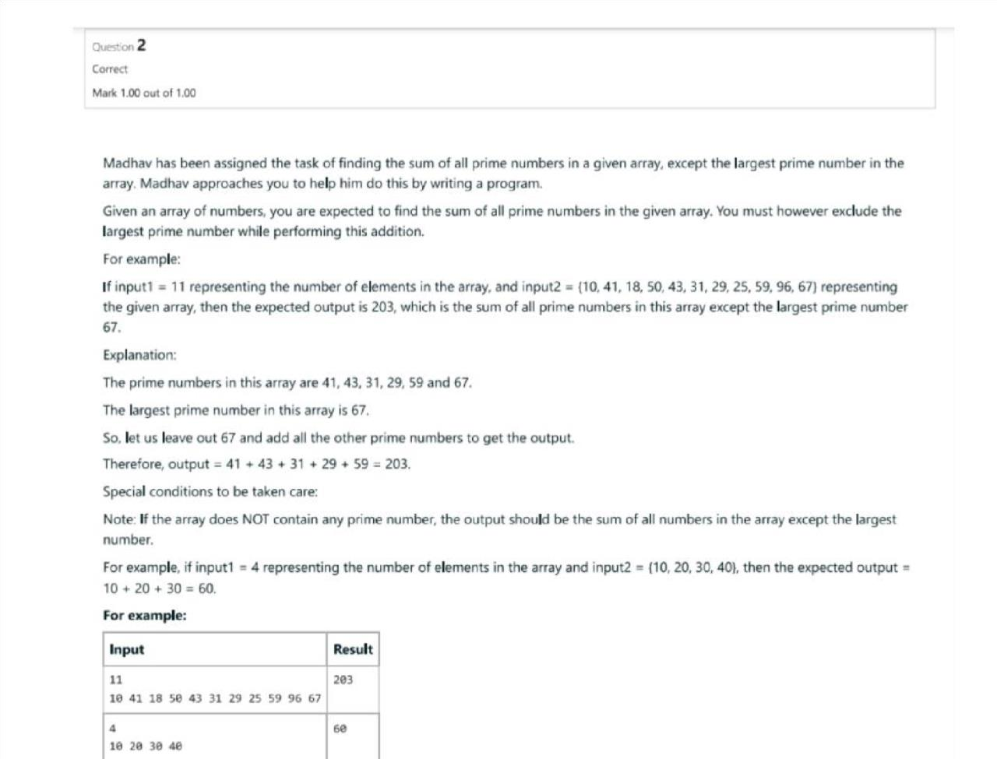

**Program:**

import java.util.Scanner;

public class PrimeSumExcludingLargest { public static void main(String[] args) { Scanner scanner = new Scanner(System.in); System.out.print("Enter the size of the array: "); int size = scanner.nextInt(); int[] array = new int[size]; int largestPrime = 0, primeSum = 0, largestElement =

Integer.MIN_VALUE;

System.out.println("Enter " + size + " elements:"); for (int i = 0; i < size; i++) { array[i] = scanner.nextInt(); if

(isPrime(array[i])) { primeSum += array[i]; if (array[i] > largestPrime) {

largestPrime = array[i];

}

}

if (array[i] > largestElement) { largestElement = array[i];

}

}

if (primeSum == 0) {

primeSum = sumArray(array) - largestElement;

System.out.println("No prime numbers found. Sum excluding the largest element: " + primeSum);

} else {

primeSum -= largestPrime;

System.out.println("Sum of primes excluding the largest prime: " + primeSum);

}

scanner.close();

}

public static boolean isPrime(int num) { if (num <= 1) return false; for (int i = 2; i * i <= num; i++) { if (num % i == 0) return false;

}

return true;

}

public static int sumArray(int[] array) {

int sum = 0; for (int num : array) {

sum += num;

}

return sum;

}

}

**Output:**

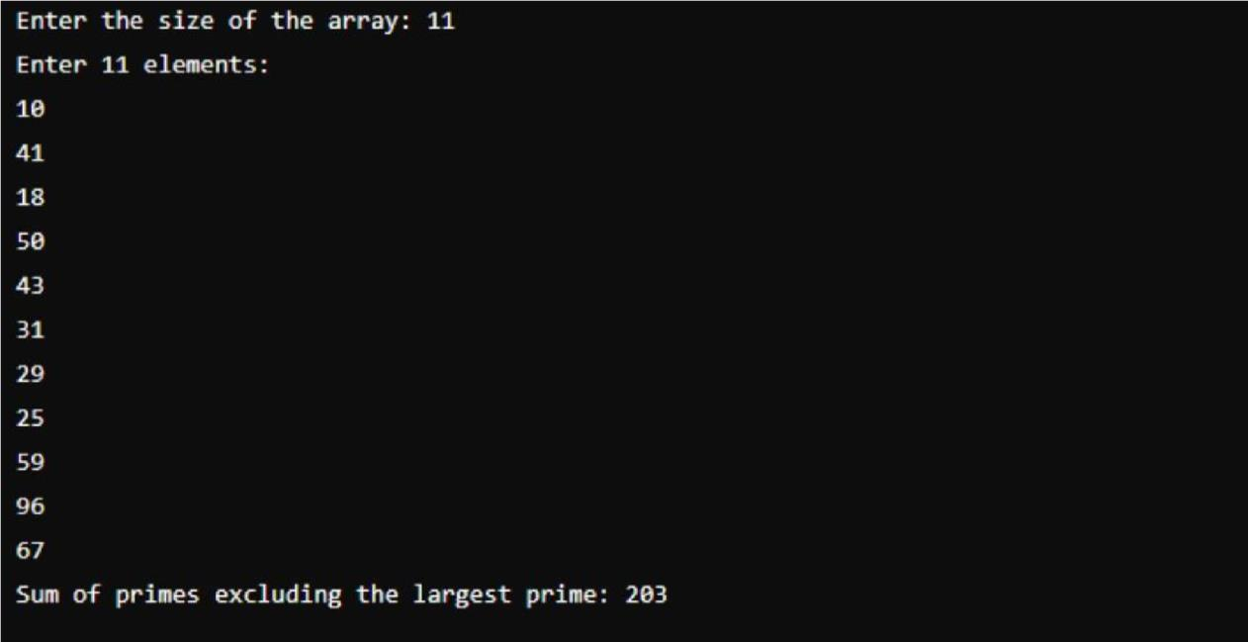

**3.**

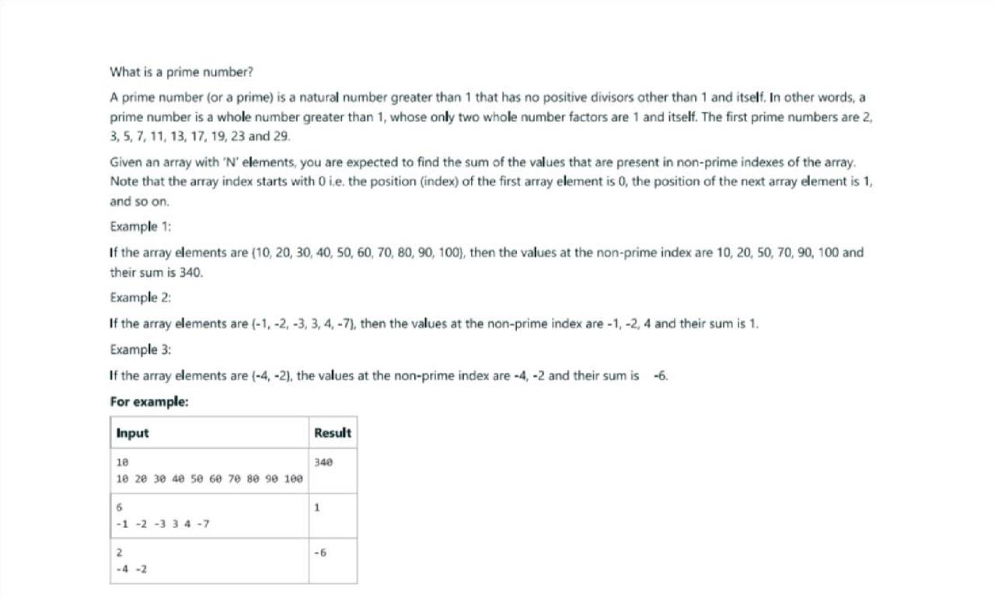

**Program:**

import java.util.Scanner;

public class SumNonPrimeIndexes { public static void main(String[] args) { Scanner scanner = new Scanner(System.in); System.out.print("Enter the size of the array: "); int size = scanner.nextInt(); int[] array = new int[size];

System.out.println("Enter " + size + " elements:"); for (int i = 0; i < size; i++) { array[i] = scanner.nextInt();

}

int sum = 0; for (int i =

0; i < size; i++) { if (!isPrime(i)) {

sum += array[i];

}

}

System.out.println("Sum of values at non-prime indexes: " + sum); scanner.close();

}

public static boolean isPrime(int num) { if (num <= 1) return false; for (int i = 2; i * i <= num; i++) { if (num % i == 0) return false;

}

return true;

}

}

**Output:**

